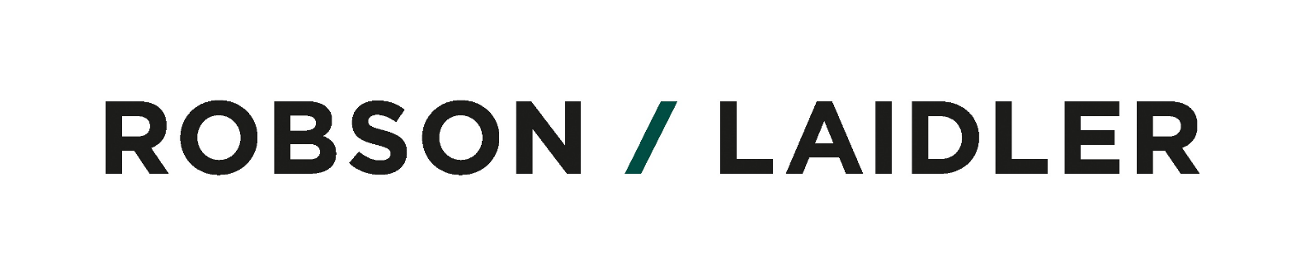

Details of amounts payable to businesses forced to close under the new national lockdown

These are given in the table overleaf. Funding will be made available to Scotland and Wales, according to the government announcement, which included ‘devolved administrations will receive Barnett consequentials which they could use to establish similar schemes.’

On 9 October, the local authority grant assistance for businesses that were forced to close their premises as a result of local lockdowns in England was largely enhanced both in terms of the frequency and amount of payment (so that ‘larger’ businesses would receive more overall), and in terms of the scope – ‘local’ went ‘national.’

In this context, ‘lockdown’ refers to a legal requirement to close as imposed by one of the national/UK governments. However, businesses such as restaurants that have been ‘locked down’ but are still permitted to carry on a ‘takeaway’ or similar service will still count as being ‘under lockdown.’

The scope was further extended on 22 October, to cover businesses that were not ‘locked down’, but were subject to significant restrictions on business activity – such as hotel and leisure facilities. The tier 2 rates are meant to approximate 70 per cent of the rates for business that are ‘under lockdown.’

We are still waiting for further details to flesh out the announcement made on 22 October, but what we know so far is set out in the table below. The table sets out the position for England. However, the UK government says it has made funding available to the devolved governments to enable them to make similar provision in their respective territories. The grant will of course be taxable, as a Coronavirus Support Payment.

5 November 2020 | 22 October 2020 |  | 9 October 2020 | 9 September 2020
NATIONAL LOCKDOWN(s) | TIER 2 – High Alert | TIER 3 Very High | LEGALLY CLOSED | LEGALLY CLOSED
From commencement of new lockdown | ‘Funding… backdated until the point at which these restrictions began.’ | ‘Funding… backdated… [etc.]’ | ‘Applies only to lockdown from 9/9/20’ (may change?) | ‘Applies only to lockdown from 9/9/20’ (may change?)
Businesses occupying premises with a rateable value less than £15,000 (etc), will receive £1,334 per month, per premises | Businesses occupying premises with a rateable value less than £15,000 (etc), will receive £934 per month, per premises | TBA | Businesses occupying premises with a rateable value less than £15,000 (etc), will receive £667, for each 2-week period of lockdown, per premises. | Businesses occupying remises with a rateable value less than £51,000 (or occupying a property or part of a property subject to an annual rent or mortgage payment of less than £51,000), will receive £1,000, for each 3-week period of local lockdown, per premises.
Businesses occupying premises with a rateable value of £15,000 or more, but still less than £51,000, (etc), will receive £2,000 per month, per premises. | Businesses occupying premises with a rateable value of £15,000 or more, but still less than £51,000, (etc), will receive £1,400 per month, per premises. |  | Businesses occupying premises with a rateable value of £15,000 or more, but still less than £51,000, (etc), will receive £1,000, for each 2-week period of local lockdown, per premises.
Businesses occupying premises with a rateable value of £51,000 or above, (etc), will receive £3,000 per month, per premises. | Businesses occupying premises with a rateable value of £51,000 or above, (etc), will receive £2,100 per month, per premises. |  | Businesses occupying premises with a rateable value of £51,000 or above, (etc), will receive £1,500, for each 2-week period of local lockdown, per premises. | Businesses occupying premises with rateable value of exactly £51,000 or above (or businesses occupying a property or part of a property subject to an annual rent or mortgage payment of exactly £51,000 or above), will receive £1,500, for each 3-week period of local lockdown, per premises.
Already applies nationally. |  |  | ‘The government is also extending the Scheme to include businesses which have been forced to close on a national, rather than a local basis’ | Nothing for businesses closed subject to nationwide restrictions
 | 5% ‘top-up’ for Local Authorities to provide support to other businesses – e.g., not on business rates list |  | Additional funds for Local Authorities to provide support to other businesses – e.g., not on business rates list | Additional funds for Local Authorities to provide support to other businesses – e.g., not on business rates list

